Unit 1: Managing Change and Innovation
- Introduction
The only constant thing in the world we are living in today is change. Change is inevitable and for survival we have to cope with it. Any new way of doing things generates some resistance by the people affected. The 21st century is dominated by technological improvements and these technologies can generate fear and resistance by employees. Change is an alteration in people, structure and technology. It is an alteration in the way things are done for improved organisational performance. This unit will define change management, explain the need of change, forces of change, nature of change and types of change.

  - Objectives
By the end of this unit you should be able to:
- Define change management
- Explain theories that have influenced change management.
- Identify the internal and external pressures for change, which drive organizations to adapt and evolve
- Discuss common areas of change
- Explain how environment scanning is carried out
- Explain Types of change and differentiate between planned and emergency change

  - Definition of Change Management
Change management is a collective term for all approaches to prepare and support individuals, teams, and organizations in making organizational change. It includes methods that redirect or redefine the use of resources, business process, budget allocations, or other modes of operation that significantly change a company or organization. Organizational change management (OCM) considers the full organization and what needs to change, while change management may be used solely to refer to how people and teams are affected by such organizational transition. It deals with many different disciplines, from behavioural and social sciences to information technology and business solutions.
The systematic approach and application of knowledge, tools and resources to deal with change. Change management means defining and adopting corporate strategies, structures, procedures and technologies to deal with changes in external conditions and the business environment.
SHRM Glossary of Human Resources Terms, www.shrm.org.
Change management is the process, tools and techniques to manage the people-side of business change to achieve the required business outcome, and to realize that business change effectively within the social infrastructure of the workplace.
Change Management Learning Center

Change Management: activities involved in (1) defining and instilling new values, attitudes, norms, and behaviors within an organization that support new ways of doing work and overcome resistance to change; (2) building consensus among customers and stakeholders on specific changes designed to better meet their needs; and (3) planning, testing, and implementing all aspects of the transition from one organizational structure or business process to another.
http://www.gao.gov/special.pubs/bprag/bprgloss.htm

....a systematic approach to dealing with change, both from the perspective of an organization and on the individual level...proactively addressing adapting to change, controlling change, and effecting change.
Case Western Reserve University

Change management is a systematic approach to dealing with change, both from the perspective of an organization and on the individual level.
searchsmb.com

The definitions of change management entail the understanding that companies all over the world are continually faced with a broad array of external challenges. The definitions shows the need to combat and maintain preparedness for global financial issues, eve-increasing competition, environmental and government regulations and so on. The definitions shows that change management evolves from the understanding of internal pressures from within our own businesses, and from our own colleagues, etc and for whatever reason, that some aspect of our businesses needs to be improving continually. Change management reflects the point that to achieve the best you possibly can, to increase the overall organizational performance, individuals and companies have to do more than just work harder constantly driving to increasing throughput. It reflects the fact that to be high performing companies, firms must be geared for achieving sustainable results fast and that means they have to be continually guiding and managing the people, structural and strategy elements towards improvement.

  - Theories that have Influenced Change Management thinking
Historical Perspectives
This section identifies some of the key theories that have influenced change management thinking over the past 100 years.
Scientific management (1910s)
Promoted change as part of achieving efficiency due to better performing the task. Employers having specific responsibilities for achieving better performance and the method encouraged the scientific selection, training, and development of workers. Taylor, who laid the foundations of the Scientific Management sought to achieve change by using the ‘carrot and stick’ approach – by connecting performance to rewards.
Classical school (1910s)
Listed the duties of a manager as planning, organising, commanding employees, coordinating activities, and controlling performance. Change would be achieved through specialisation of work, unity of command, and coordination of activities.
The individual perspective school (1920s)
Change can be achieved by changing the behaviour of individuals.
Human relations school (1920s)
Change (influencing performance) by changing informal roles and norms and understanding the attitudes and feelings of workers.
The group dynamics school (1940s)
Change can be achieved by changing the groups and teams, rather than the individuals.
Bureaucracy (1940s)
Change through adherence to procedures, policies. Rationality, uniformity, and consistency in management lead to equitable treatment for all employees.
Leadership (1950s)
Stressed the importance of groups having both social task leaders; differentiated between Theory X and Y management.
Decision theory (1960s)
Suggested that individuals “satisfice” when they make decisions. Participation in decision-making an enabler of change.
Socio-technical school (1960s)
Change introduced through technology and work groups.
Systems theory (1970s)
Represented organisations as open systems with inputs, transformations, outputs, and feedback. Two approaches: hard systems and soft systems.
Contingency theory (1980s)
Change can be successful and drive the organisation forward, if there is a fit between organization processes and characteristics of the situation.
Chaos and complexity theory (1990s)
Organisations viewed as complex adaptive systems. Effects of change difficult to predict. Emphasis on creating the conditions for beneficial change to occur.

  - Forces that Drive Change
Internal and external forces drive change.
    - The internal environment
The internal environment of an organization refers to events, factors, people, systems, structures, and conditions inside the organization that are generally under the control of the company. The company's mission statement, organizational culture, and style of leadership are factors typically associated with the internal environment of an organization. As such, it is the internal environment that will influence organizational activities, decisions, and employee behavior and attitudes. Changes in the leadership style, the organization's mission, or culture can have a considerable impact on the organization.
There are many inside forces to keep in mind as well, ranging from employee changes to cultural reform to operational challenges. Understanding where this change is coming from is the first step to timely and appropriate change management.
Management Change – New CEOs or other executive players can significantly impact strategy and corporate culture. Understanding the risks associated with hiring (or promoting for) new upper management is key to making a good decision on best fit.
Organizational Restructuring – Organizations may be required to significantly alter their existing structure to adapt to the development of new strategic business units, new product lines, or global expansion. Changing structure means disrupting hierarchies and communications, which must then be reintegrated. Employees must be trained on the change and the implications it will have for their everyday operations.
Intrapreneurship – New ideas come from inside the organization as well as outside the organization, and capitalizing on a great new idea will likely require some internal reconsideration. Integrating a new idea may require reallocation of resources, new hires and talent management, and new branding.
    - The external Environment
The external environment are those factors that occur outside of the company that cause change inside organizations and are, for the most part, beyond the control of the company. Customers, competition, the economy, technology, political and social conditions, and resources are common external factors that influence the organization. Even though the external environment occurs outside of an organization, it can have a significant influence on its current operations, growth, and long-term sustainability. Ignoring external forces can be a detrimental mistake for managers to make. As such, it is imperative that managers continually monitor and adapt to the external environment, working to make proactive changes earlier on rather than having to take a reactive approach, which can lead to a vastly different outcome.
Below are explanations on how the external environments acts as forces of change
Economics – The 2008 economic collapse is a strong example of why adaptability is important. As consumers tightened their belts, organizations had to either do the same and lower supply to match lowered demand, or come up with new goods to entice them. Migrating from one volume to another can financially challenging, and change strategies such as creating new affordable product lines or more efficient operational paradigms are key to changing for success.
Competition – Changes in the competitive landscape, such as new incumbents, mergers and acquisitions, new product offerings, and bankruptcies, can substantially impact a company’s strategy and operations. For example, if a competitor releases a new product that threatens to steal market share, an organization must be ready to change and adapt to retain their customer base.
Technology – Technological changes are a constant threat, and embracing new technologies ahead of the competition requires adaptability. When media went digital, adaptable companies found ways to evolve their operations to stay competitive. Many companies that could not evolve quickly failed. For example the use of MyVista by Zimbabwe Open University.
Globalization – Capturing new global markets requires product, cultural, and communicative adaptability. Catering to new demographics and identifying opportunities and threats as they appear in the global market is integral to adapting for optimal value.
Legislation – New laws and legislation can dramatically change operations. Companies in industries that impact the environment must constantly strive to adapt to cleaner and more socially responsible operating methodologies. Failing to keep pace can result in substantial fines and financial detriments, not to mention negative branding. For example the ammendments of Labour Law e.g the Zuva case etc.

  - Environmental Scanning and Change
Organizational environment consists of both external and internal factors. Environment must be scanned so as to determine development and forecasts of factors that will influence organizational success. Environmental scanning refers to possession and utilization of information about occasions, patterns, trends, and relationships within an organization’s internal and external environment. It helps the managers to decide the future path of the organization. Scanning must identify the threats and opportunities existing in the environment. While strategy formulation, an organization must take advantage of the opportunities and minimize the threats. A threat for one organization may be an opportunity for another.
Internal analysis of the environment is the first step of environment scanning. Organizations should observe the internal organizational environment. This includes employee interaction with other employees, employee interaction with management, manager interaction with other managers, and management interaction with shareholders, access to natural resources, brand awareness, organizational structure, main staff, operational potential, etc. Also, discussions, interviews, and surveys can be used to assess the internal environment. Analysis of internal environment helps in identifying strengths and weaknesses of an organization.
As business becomes more competitive, and there are rapid changes in the external environment, information from external environment adds crucial elements to the effectiveness of long-term plans. As environment is dynamic, it becomes essential to identify competitors’ moves and actions. Organizations have also to update the core competencies and internal environment as per external environment. Environmental factors are infinite, hence, organization should be agile and vigile to accept and adjust to the environmental changes. For instance - Monitoring might indicate that an original forecast of the prices of the raw materials that are involved in the product are no more credible, which could imply the requirement for more focused scanning, forecasting and analysis to create a more trustworthy prediction about the input costs. In a similar manner, there can be changes in factors such as competitor’s activities, technology, market tastes and preferences.

While in external analysis, three correlated environment should be studied and analyzed that is
- immediate / industry environment
- national environment
- broader socio-economic environment / macro-environment

Examining the industry environment needs an appraisal of the competitive structure of the organization’s industry, including the competitive position of a particular organization and its main rivals. Also, an assessment of the nature, stage, dynamics and history of the industry is essential. It also implies evaluating the effect of globalization on competition within the industry. Analyzing the national environment needs an appraisal of whether the national framework helps in achieving competitive advantage in the globalized environment. Analysis of macro-environment includes exploring macro-economic, social, government, legal, technological and international factors that may influence the environment. The analysis of organization’s external environment reveals opportunities and threats for an organization.
Strategic managers must not only recognize the present state of the environment and their industry but also be able to predict its future positions.

    - SWOT analysis is a type of environmental scanning
In order for managers to react to the forces of internal and external environments, they rely on environmental scanning. Environmental scanning refers to the monitoring of the organization's internal and external environments for early signs that a change may be needed, to accommodate potential opportunities or threats, and to make adjustments to allow the company's strengths to combat its weaknesses. If you recall, one common type of environmental scan is the SWOT analysis, which looks specifically into the strengths, weaknesses, opportunities, and threats of the internal and external environments. A manager will begin analyzing the internal environment by looking into inefficiencies inside the organization, and will then look outside to the external environment and things occurring independent of the organization. Environmental scans allow managers to use the knowledge gained during the scanning process to decide what strategic steps, or changes, the organization needs to take to create or maintain a competitive advantage.

  - Common Areas of Change
Common areas of organizational change include:
- Mission
- Strategy
- Operational changes, including structure and hierarchies
- Technology
- Culture
- Employees and/or management
- Work flows (particularly relevant in manufacturing)
- Branding
Organizational change management should begin with a systematic diagnosis of the existing situation in order to determine the organization’s need for and ability to change. The objectives, content, and process of change should be specified as part of the change management plan.
Change management processes can benefit from creative marketing to facilitate communication between change audiences and a deep social understanding of leadership styles and group dynamics. To track transformation projects, organizational change management should align group expectations, communicate, integrate teams, and manage and train people. Change management should also make use of performance metrics including financial results, operational efficiency, leadership commitment, communication effectiveness, and the perceived need for change in order to design appropriate strategies that make the change in organizational culture as smooth and as efficient as possible.

Activity 1.1
- Define change management
- Explain the internal and external forces for change
- Discuss common areas of change
- Explain how change agents can scan the environment

  - Types of Change
There are a number of ways in which change can be categorised, most are related to the extent of the change and whether it is seen as organic (often characterised as bottom-up) or driven (top-down).
    - Ackerman (1997) has distinguished between three types of change:
- Developmental – May be either planned or emergent; it is first order, or incremental. It is change that enhances or corrects existing aspects of an organisation, often focusing on the improvement of a skill or process
- Transitional – Seeks to achieve a known desired state that is different from the existing one. It is episodic, planned and second order, or radical. Much of the organisational change literature is based on this type
- Transformational – Is radical or second order in nature. It requires a shift in assumptions made by the organisation and its members. Transformation can result in an organisation that differs significantly in terms of structure, processes, culture and strategy. It may, therefore, result in the creation of an organisation that operates in developmental mode – one that continuously learns, adapts and improves.
    - Planned versus emergent change
Sometimes change is deliberate, a product of conscious reasoning and actions – planned change. In contrast, change sometimes unfolds in an apparently spontaneous and unplanned way. This type of change is known as emergent change. Change can be emergent rather than planned in two ways:
Managers make a number of decisions apparently unrelated to the change that emerges. The change is therefore not planned. However, these decisions may be based on unspoken, and sometimes unconscious, assumptions about the organisation, its environment and the future (Mintzberg, 1989) and are, therefore, not as unrelated as they first seem. Such implicit assumptions dictate the direction of the seemingly disparate and unrelated decisions, thereby shaping the change process by ‘drift’ rather than by design.
- External factors (such as the economy, competitors’ behaviour, and political climate) or internal features (such as the relative power of different interest groups, distribution of knowledge, and uncertainty) influence the change in directions outside the control of managers. Even the most carefully planned and executed change programme will have some emergent impacts.
This highlights two important aspects of managing change.
- The need to identify, explore and if necessary challenge the assumptions that underlie managerial decisions.
- Understanding that organisational change is a process that can be facilitated by perceptive and insightful planning and analysis and well crafted, sensitive implementation phases, while acknowledging that it can never be fully isolated from the effects of serendipity, uncertainty and chance (Dawson, 1996).
Emergent change is a strategy of quickly developing and shipping working features and improvements. Planned change is a strategy of planning and implementing long term strategies that may involve multi-year programs and projects.

Emergent change is quick to respond to industry drivers such as markets, customer preferences, technology, risk factors and competition. Planned change allows for rigorous strategic planning, architecture, design, project management and risk management processes. The choice between the two depends on the nature of an initiative. Generally, emergent change addresses a need to innovate and planned change addresses a need for scale, structure and risk management.

EMERGENCY CHANGE VERSUS PLANNED CHANGE
Emergent Change | Responsive to changing strategic drivers.  Tends to be more innovative.  Releases can be designed to fail well.  Associated with lower quality.  Often results in an ad hoc architecture and design.  Regression testing can be a challenge.
Planned Change | Essential for large scale projects such as a bridge or space mission.  Allows for a consistent architecture and design.  Large releases may fail poorly.  Allows for a diligent strategy, architecture and design.  Less responsive to change.  Associated with more rigorous designs, risk management processes and quality assurance testing.

    - Episodic versus continuous change
Another distinction is between episodic and continuous change. Episodic change, according to Weick and Quinn (1999), is ‘infrequent, discontinuous and intentional’. Sometimes termed ‘radical’ or ‘second order’ change, episodic change often involves replacement of one strategy or programme with another.
Continuous change, in contrast, is ‘ongoing, evolving and cumulative’. Also referred to as ‘first order’ or ‘incremental’ change, continuous change is characterised by people constantly adapting and editing ideas they acquire from different sources. At a collective level these continuous adjustments made simultaneously across units can create substantial change.
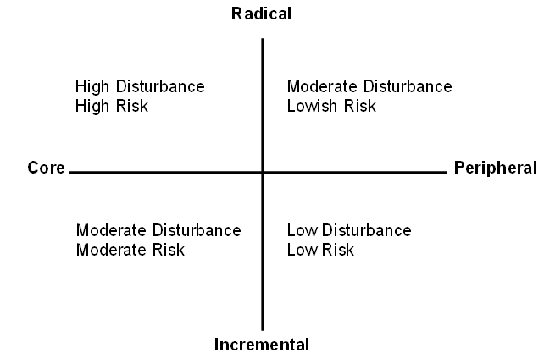
Creative Commons attribution information
The distinction between episodic and continuous change helps clarify thinking about an organisation’s future development and evolution in relation to its long-term goals. Few organisations are in a position to decide unilaterally that they will adopt an exclusively continuous change approach. They can, however, capitalise upon many of the principles of continuous change by engendering the flexibility to accommodate and experiment with everyday contingencies, breakdowns, exceptions, opportunities and unintended consequences that punctuate organisational life (Orlikowski, 1996).
Using these characteristics proposed changes can be placed along two scales: radical – incremental and core – peripheral (Pennington 2003) Plotting the character of a proposed change along these scales can provide a sense of how difficult the introduction of any particular initiative might be and how much disturbance to the status quo it might generate. Radical changes to an institution’s or department’s core business will normally generate high levels of disturbance; incremental changes to peripheral activities are often considered to be unexceptional and can be accommodated as a matter of course, especially if the group involved has a successful past record of continuous improvement.

Activity 1.2
  - Explain Ackerman (1997) has three types of change
  - Differentiate between planned and emergency change
  - Discuss common areas of change.
  - Distinguish between episodic and continuous change

  - Summary
Change management is the organizational activity that should be engrained in the firm as a part of the way we do business everyday. Change management is an approach to shifting individuals, teams, and organizations to a desired future state. Examples of organizational change can include strategic, operational, and technological change that can come from inside or outside the organization. Outside forces for change include macroeconomics, technological evolution, globalization, new legislation, and competitive dynamics. Inside forces for change include intrapreneurship, new management and restructuring. Common areas of organizational change include: Mission, strategy, operational changes, including structure and hierarchies, technology, culture, employees and/or management, Work flows (particularly relevant in manufacturing). Emergent change is a strategy of quickly developing and shipping working features and improvements. Planned change is a strategy of planning and implementing long term strategies that may involve multi-year programs and projects.

Reference
Ackerman, L. (1997) Development, transition or transformation: the question of change in organisations. In: Van Eynde, D., Hoy, J. and Van Eynde, D. (eds) Organisation Development Classics. San Francisco, Jossey Bass.

Dawson, S.J.N.D. (1996) Analysing Organisations. Hampshire, Macmillan.

Mintzberg, H. (1989) Mintzberg on Management: inside our strange world of organisations Chicago, Free Press.

Orlikowski, W. (1996) Improvising organisational transformation over time: a situated change perspective. Information Systems Research, 7(1), p63-92.

Pennington, G. (2003) Guidelines for Promoting and Facilitating Change, LTSN Generic Centre. Available at: http://www.heacademy.ac.uk/…/id296_Promoting_and_facilitating_change.pdf

Weick, K. E. and Quinn, R. E. (1999) Organisational change and development. Annual Review of Psychology, 50 p361-86.

http://www.gao.gov/special.pubs/bprag/bprgloss.htm
SHRM Glossary of Human Resources Terms, www.shrm.org.

UNIT 2 MAJOR APPROACHES & MODELS OF CHANGE MANAGEMENT
- Introduction
There are a lot of change management models that organisations may use inorder to manage change. In order to manage change and implement change strategies, it is important to avoid implementing irrelevant or random methods and try to focus on a suitable plan of action. This unit will introduce some of the best models of change management.

  - Objectives

At the end of this unit you should be able to explain and know when best to use the following models:
- Kurt Lewin’s Change Management Model
- McKinsey 7 S Model
- Kotter’s Change Management Theory
- Nudge theory
- ADKAR model
- Bridges’ Transition Model
- Kübler-Ross Five Stage Model

  - Kurt Lewin’s Change Management Model
Lewin’s Change Management Model is one of the most popular and effective models that make it possible for us to understand organizational and structured change. Lewin was a physicist and social scientist who explained the structured or organizational change through the changing states of a block of ice.
Lewin's three stage theory of change is commonly referred to as Unfreeze, Change, Freeze (or Refreeze). The world has changed since the theory was originally presented in 1947, but the Kurt Lewin model is still extremely relevant. Many other modern change models are actually based on the 3-stage Lewin model. Below is a pictorial diagram of the model
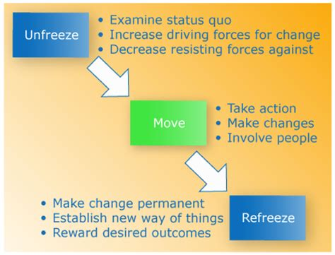
Figure 2.1 Kurt Lewins Change Management 1
Source: Kotter, J. (1995) Leading Change

    - Unfreeze
The first stage of the process of change according to Lewin’s method involves the preparation for the change. This means that at this step, the organization must get prepared for the change and also for the fact that change is crucial and needed. This phase is important because most people around the world try to resist change, and it is important to break this status quo. The key here is to explain to people why the existing way needs to be changed and how change can bring about profit. This step also involves an organization looking into its core and re-examining it.
This first stage is about preparing people, before the change. The more people feel that change is necessary, the more urgent it is, the more motivated they become to make the change. With the deadline comes some sort of reward or punishment linked to the job. If there's no deadline, then the urge to change is lower than the need to change. There's much lower motivation to make a change. If there's no urgency or motive to change most of us will do nothing.

    - Change:
This is the stage where the real transition or change takes place. The process may take time to happen as people usually spend time to embrace new happenings, developments, and changes. At this stage, good leadership and reassurance is important because these aspects not only lead to steer forward in the right direction but also make the process easier for staff or individuals who are involved in the process. Communication and time thus are the keys for this stage to take place successfully.
    - Refreeze
Now that the change has been accepted, embraced and implemented by people, the company or organization begins to become stable again. This is why the stage is referred to as refreeze. This is the time when the staff and processes begin to refreeze, and things start going back to their normal pace and routine. This step requires the help of the people to make sure changes are used all the time and implemented even after the objective has been achieved. Now with a sense of stability, employees get comfortable and confident of the acquired changes.

  - McKinsey 7 S Model
McKinsey 7-S framework or model is one of those few models that have managed to persist even when others came in and went out of trend. It was developed by consultants working for McKinsey & Company in the 1980s and features seven steps or stages for managing change. Below is a figure of the framework.
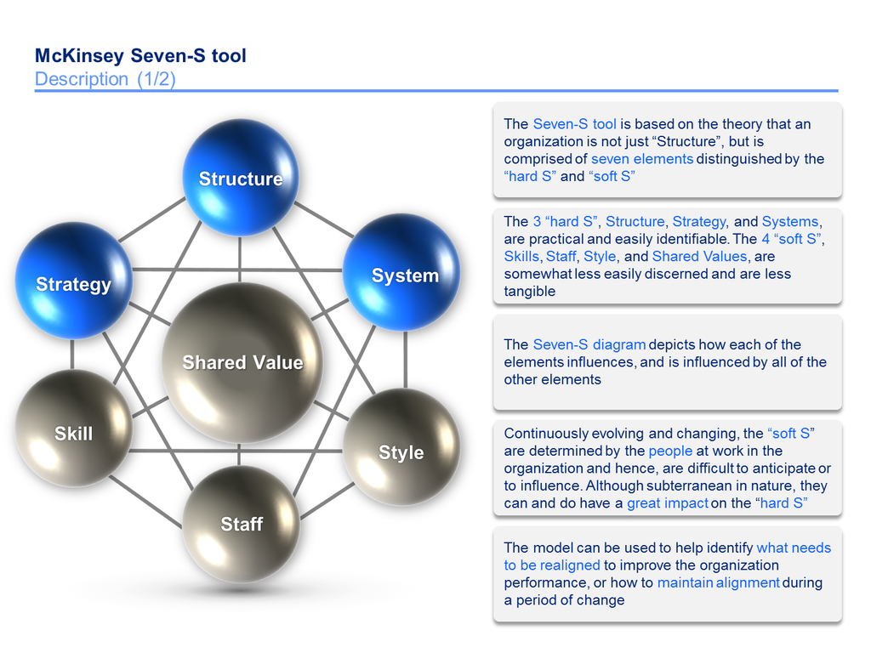
Figure 2.2 McKinsey Seven S Model 1
Source: Kotter, J. (1995) Leading Change
Stages
Strategy – Strategy is the plan created to get past the competition and reach the goals. This is the first stage of change according to McKinsey’s 7-S framework and involves the development of a step-by-step procedure or future plan.
Structure – Structure is the stage or attribute of this model that relates to the way in which the organization is divided or the structure it follows.
Systems – In order to get a task done, the way in which the day-to-day activities are performed is what this stage is related to.
Shared values – Shared values refer to the core or main values of an organization according to which it runs or works.
Style – The manner in which the changes and leadership are adopted or implemented is known as ‘style’.
Staff – The staff refers to the workforce or employees and their working capabilities.
Skills – The competencies as well as other skills possessed by the employees working in the organization.

    - Benefits of this model McKinsey’s 7-S framework
There are a lot of benefits that come along with McKinsey’s 7-S framework
- It offers ways and methods to understand an organization and get a deep insight into the way it works.
- It integrates both the emotional as well as the practical components of change that is something that is important to create ways to enable employees deal with transition easily.
- The model considers all parts to be important and equally worth addressing and thus does not leave out some aspects that may be of importance.
- It also offers directional factor to organizational change.

    - Disadvantages of the McKinsey’s 7-S framework
- Since all the factors are interrelated and interdependent on one another, the failing of one part means failing of all and this is the greatest disadvantage of this model.
- This model is complex as compared to the others and differences are not focused upon in it.
- Organizations that have used this model have experienced more cases of failure, and this too can be considered as one negative associated with it.

  - Kotter’s Change Management Theory
Kotter’s change management theory is one of the most popular and adopted ones in the world. This theory has been devised by John P. Kotter, who is a Harvard Business School Professor and author of several books based on change management. This change management theory of his is divided into eight stages where each one of them focuses on a key principle that is associated with the response of people to change.

    - Stages in Kotter’s change management theory
Increase urgency – This step involves creating a sense of urgency among the people so as to motivate them to move forward towards objectives.
Build the team – This step of Kotter’s change management theory is associated with getting the right people on the team by selecting a mix of skills, knowledge and commitment.
Get the vision correct – This stage is related to creating the correct vision by taking into account, not the just strategy but also creativity, emotional connect and objectives.
Communicate – Communication with people regarding change and its need is also an important part of the change management theory by Kotter.
Get things moving – In order to get things moving or empower action, one needs to get support, remove the roadblocks and implement feedback in a constructive way.
Focus on short term goals – Focusing on short term goals and dividing the ultimate goal into small and achievable parts is a good way to achieve success without too much pressure.
Don’t give up – Persistence is the key to success, and it is important not to give up while the process of change management is going on, no matter how tough things may seem.
Incorporate change – Besides managing change effectively, it is also important to reinforce it and make it a part of the workplace culture.

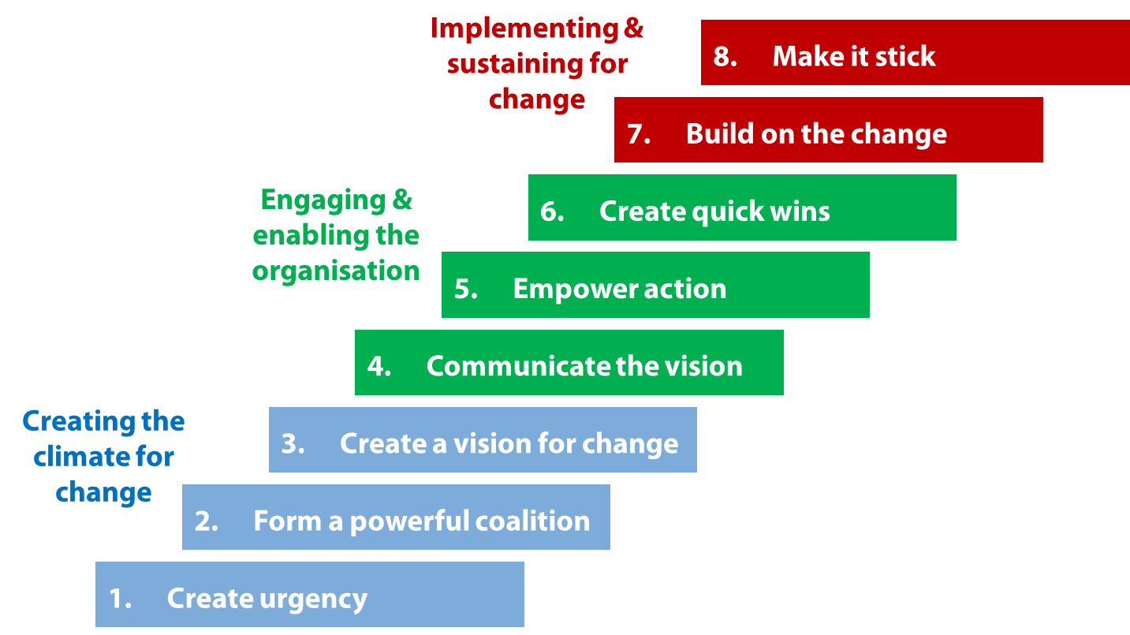
Figure 2.3 Kotter's Change Mgt Theory 1
Source: Kotter, J. (1995) Leading Change
    - Benefits of Kotter’s change management theory
- This is a step-by-step model that is easy to follow and incorporate.
- The main idea behind it is to accept the change and prepare for it rather than changing itself.

    - Disadvantages of this model
- Since it is a step-by-step model, no step can be skipped to reach the one after that.
- The entire process given in this model can be very time-consuming.

Activity 2.1
  - Explain Kurt Lewins change management model.
  - Explain McKinsey 7-S framework
  - Discuss the benefits and challenges of using for managing chang McKinsey 7-S framework for managing change.
  - Discuss Kotters change management theory.

  - Nudge Theory
Nudge Theory or Nudge is a concept that finds use in behavioral science, economics, and political theory but can be applied to change management in organizations and businesses as well. This theory is mainly credited to Cass R. Sunstein and Richard H. Thaler. Nudging someone or encouraging and inspiring them to change is the basic essence of this theory. Nudge theory is not only helpful in exploring and understanding existing influences but also explaining them to either eliminate them or change them to an extent where positives may begin to be derived.
It is important to note that there are many unhelpful ‘nudges’ around which can either be deliberate or may just be accidental. What this theory mainly seeks is to work upon the management as well as the understanding of the many influences on human behavior that lead to the changing people. It focuses on the design of choices which is responsible for directing our preferences and influencing the choices that we make. What this theory says is that choices must be designed in such a way that it can be aligned with the way people think and decide.
As compared to other theories, Nudge Theory is more sophisticated in its approach and is radically different from other ways of transitioning. This theory eliminates traditional change methods like punishment enforcement and direct instructions. One of the main benefits of this theory is that it takes into account the difference in feelings, opinions, and knowledge of people and also considers the reality of the situation as well as the characteristics of human nature and behavior. It thus minimizes resistance from employees of a company and is very well applied in several industries.
  - ADKAR model
ADKAR Model basically stands for
Awareness – of the need and requirement for change
Desire – to bring about change and be a participant in it
Knowledge – of how to bring about this change
Ability – to incorporate the change on a regular basis
Reinforcement – to keep it implemented and reinforced later on as well.

ADKAR model or theory of change is a goal-oriented tool or model which makes it possible for the various change management teams to focus on those steps or activities that are directly related to the goals it wants to reach to. The goals, as well as the results derived and defined using this model, are cumulative and in a sequence. This means that while using this model, an individual must get each of the outcomes or results in a certain orderly fashion so that the change can be sustained and implemented. The model can be used by managers of change to find out the various holes or gaps in the process of change management so that effective training can be offered to the employees. The following are some of the things for which this model can be used:
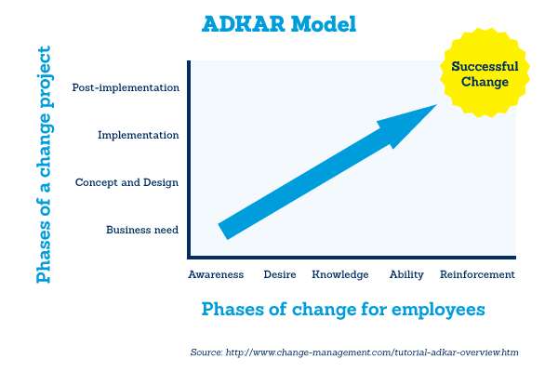
Figure 2.4 ADKAR Model 1
2.6.1 Benefits of ADKAR model
- The model offers the capability of Identification and evaluation of the reasons why changes made are not working and why desired results are not being obtained.
- The model makes it possible for one to break the changes into different parts and then figure out the point where change may not be as effective as planned.
- It offers both business dimension of change as well as people dimension of change.

  - Bridges’ Transition Model
Bridges ‘transition model was developed by William Bridges who is a change consultant, and this theory came into the eye of the public after it was published in the book “Managing transitions”. The specialty of this model or theory is that it concentrates and focusses upon transition and not change as such. The difference between transition and change may be subtle, but it is important to understand it. Where transition on one hand is internal, change on the other is something that happens to people, even when they don’t realize it. Transition is something that happens to people when they are going through the change. Change can be instant, transition may take time.
The model focuses on three main stages that are given as follows:
Ending, Losing, and Letting Go – When people are first introduced to change, they may enter this first stage that is marked with resistance and emotional discomfort. Some of the emotions experienced at this stage include fear, resentment, anger, denial, sadness, frustration and most of all-disorientation. One has to realize that he/she is coming near to a certain end so as to accept new beginnings.
The Neutral Zone – This is the stage of uncertainty, impatience, and confusion. This stage can be considered as the bridge between the old and the new when people are still attached to the old but trying to adapt to the new. This stage is associated with low morale and reduced productivity, and one may experience anxiety and skepticism as well when going through this stage. But despite this, the neutral zone may also include innovation, renewal and a burst of creativity.
The New Beginning – When the neutral phase is passed through support and guidance, the stage of acceptance and energy enters the picture. At this level, people begin to embrace the change and understand its importance. They are beginning to build the skills needed to reach the new goals and may start to experience benefits of the change already. It is associated with high levels of energy, new commitment and a zest to learn.

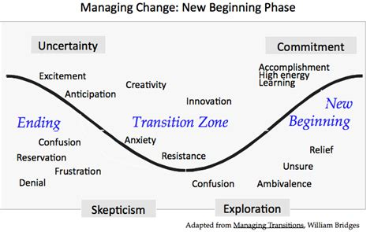
Figure 2.5 Bridges Transition Model 1
  - Kubler-Ross Five Stage Model
The Kubler-Ross five stage model was developed by Elisabeth Kübler-Ross after she pursued her research on the dying and death. This model is also thus known as the Grief Model as it talks about the various emotional states and stages a person goes through when he/she discovers that he/she may be nearing their end. The model can also be applied to other life situations such as loss of job, changes in work and other less serious health conditions. The model helps to understand and deal with personal trauma and has been widely accepted worldwide. The following are the various stages that are associated with the Kübler-Ross model:

  - Denial – Denial is the first stage of the model and is a stage when one is unable to accept the news. It is like a buffer or defense that a person tends to create due to the inability to absorb the news. One may experience shock as well as a sense of numbness during this stage and this happens because every person shows resistance towards change and may not want to believe what is happening.

  - Anger – When the news actually gets absorbed, then the first reaction is usually that of anger. The denial converts into anger when one realizes that the change will actually affect them and is for real. One starts looking for someone to blame during this stage. For different people, there can be different ways of directing anger.

  - Bargaining – The next step or stage involves bargaining so as to avail the best possible solution out of the situation or circumstance. Bargaining is a way for people to avoid ending up with the worst case scenario and is a natural reaction to avoid the extreme change.

  - Depression – When one realizes that bargaining isn’t working, he/she may end up getting depressed and may lose all faith. This is the phase when one is not bothered by anything and moves into a sad and hopeless state of mind. There are many ways to observe or identify depression and some of them include low energy, non-commitment, low motivation and lack of any kind of excitement or happiness.

  - Acceptance – When one realizes that there is no point in being depressed or resisting change, he/she may finally accept what is happening and may begin to resign to it. There are different ways in people handle this stage. While some may begin to explore the options left with them to make the most of the situation, others may just feel that no option is left for them and may just resign to destiny.

Activity 2.2
- Explain the Nudge theory of concept in relation to managing change
- Explain the ADKAR model
- Compare and contrast Kurt Lewin model of change and Bridges’ Transition Model
- Discuss Kubler-Ross Five Stage Model
Summary
It is of paramount importance that every change agent understands the change management models. They aid in managing change successfully. Below are some of the models that assists in managing change.

• Kurt Lewin’s Change Management Model
• McKinsey 7 S Model
• Kotter’s Change Management Theory
• Nudge theory
• ADKAR model
• Bridges’ Transition Model
• Kubler-Ross Five Stage Model

Reference

Lewin, R. and Regine, B. (1999) The Soul at Work: Unleashing the power of complexity science for business success. Orion Business.

Kotter, J. (1995) Leading Change: Why Transformation Efforts Fail, Harvard Business Review, March-April.

Bridges, W. (1998) Leading Organizational Transitions. Available at: http://www.wmbridges.com

http://www.change–mgt.com

Unit 3 Change Resistance
- Introduction
Naturally people find it hard to easily accept change due to many different reasons. Employees accept and handle change depending on a number of factors which include the reason behind the change, the leader making the change, and the personality of the person being changed. We will discuss these things in this unit. Implementing change, creating an Atmosphere for Change, Communicating Details
  - Objectives
In this unit, you will learn the following:
- The definition of resistance to change
- Types of resistance to change
- Reasons why employees resist change
- How to overcome resistance to change
- Models of managing change
- Benefits of change

  - Resistance to Change
Change resistance is the tendency for something to resist change even when a large amount of force is applied. There are two forms of resistance to change and these are individual and systemic change resistance. Individual change resistance is the refusal of a social agent (a single person, organization, corporation, etc) to fully support or adopt new behavior. Systemic change resistance is the tendency for a system as a whole to reject an attempted change, even if that change is promoted over a long period of time by a substantial fraction of the population.
Resistance to change consists of any employee behaviors designed to discredit, delay, or prevent the implementation of a work change. Employees resist change because it threatens their needs for:
• Security Social Interaction
• Status
• Competence
• Self-Esteem

  - Types of Resistance to change
There are three main types of resistance to change in organizations and these are
- Logical and rational,
- Psychological and emotional, and
- Sociological resistance.

    - Logical and Rational Resistance
These resistances are the outcomes of disagreement with rational facts, rational reasoning, logic, and science. These arise from the actual time and effort required to adjust to change including new job duties that must be learned. These are too costly which might be borne by the common employees and managers. Even though the change may be beneficial for the employees in the long run. But the short run costs for change must be paid first. Logical resistance to change include the following:
- The time required to adjust
- Extra efforts to relearn
- The possibility of a less desirable condition
- Economic costs of change
- Questionable technical feasibility of change
    - Psychological Resistance
These types of resistances are typically based on emotion and attitude. It is internally logical from the perspective of the employee attitude and feelings about change. Employees may fear the unknown, mistrust management, or feel that their security and ego needs are threatened. Even though management may believe that there is no justification for these feelings they are very rational to employees, and as such managers must deal with them. Psychological or emotional resistance may take place in the following manner:
- Fear of unknown
- Low tolerance for change
- Dislike of management/change agent
- Lack of trust in other
- Need for security
- The desire for status quo

3.2.3 Sociological Resistance

Sociological resistance may sometimes be logical. This happens when it is seen as a product of challenge to group interests, norms, and values. Since social values are a powerful force in the environment, they must be carefully considered. On a small group level, there is work friendship and relationships that may disrupt buy change. Then resistance occurs. However, sociological resistance includes the following:
- Political coalitions
- Opposing group values
- Parochial/narrow outlook
- Vested interest
- The desire to retain existing friendships
Whatever may be the types of resistance, managers should be very careful and tolerant. Tolerance sometimes helps the employees to realize the need for change and employees accept that.
  - Reasons why employees Resist change
There are a number of reasons why employees or mangers resist the change. These include:
Misunderstanding about the need for change/when the reason for the change is unclear. If staff do not understand the need for change you can expect resistance. Especially from those who strongly believe the current way of doing things works well…and has done for twenty years.
- Fear of the unknown: One of the most common reasons for resistance is fear of the unknown. People will only take active steps toward the unknown if they genuinely believe and perhaps more importantly, feel that the risks of standing still are greater than those of moving forward in a new direction
- Lack of competence: This is a fear people will seldom admit. But sometimes, change in organizations necessitates changes in skills, and some people will feel that they won’t be able to make the transition very well
- Connected to the old way: If you ask people in an organization to do things in a new way, as rational as that new way may seem to you, you will be setting yourself up against all that hard wiring, all those emotional connections to those who taught your audience the old way and that’s not trivial
- Low trust: When people don’t believe that they, or the company, can competently manage the change there is likely to be resistance
- Not being consulted: If people are allowed to be part of the change there is less resistance. People like to know what’s going on, especially if their jobs may be affected. Informed employees tend to have higher levels of job satisfaction than uninformed employees
- Poor communication: Communication is key in managing change. When it comes to change management there’s no such thing as too much communication
- Exhaustion/Saturation: People who are overwhelmed by continuous change resign themselves to it and go along with the flow. You have them in body, but you do not have their hearts. Motivation is low
- Change in the status quo: Resistance can also stem from perceptions of the change that people hold. For example, people who feel they’ll be worse off at the end of the change are unlikely to give it their full support. Similarly, if people believe the change favours another group/department/person there may be (unspoken) anger and resentment
- Benefits and rewards: When the benefits and rewards for making the change are not seen as adequate for the trouble involved
- Method used: Sometimes unacceptable method is used to make change pan and implement it. The concerned people who are not habituated with that method, may protest against change.
- Threat of self-interest: If the employees self interest in threatened in regard to new assignment for higher training aboard, distribution of responsibility resistance may be shown.
- Ego involvement: Ego is sometimes the worst enemy of a human being. Ego involvement may create the people to be reckless and uncompromising and change then may be resisted.
- The Reason Behind the Change: The reason behind the change often affects acceptance of change.
- The Person Making the Change: Another factor affecting employees’ acceptance of change is the person making or suggesting the change. Changes proposed by leaders who are well liked and respected and who have a history of success are more likely to be accepted than changes proposed by leaders whose motives are doubted.
- The Person Being Changed: There is considerable variability in the way in which people instigate or react to change.
Activity 3.1
- Explain the term resistance to change.
- Discuss the three main types of resistance to change in organizations,
- Logical and rational,
- Psychological and emotional, and
- Sociological resistance.
- Discuss any five reason why people resist change

  - How to overcome resistance to change
Resistance is usually used for negative or in some cases destructive purposes. It may be harmful for the peer relationship, productivity and many. So management must come forward to overcome the resistance as early as possible.

According to Sussan Heathfield 2012 she stated that resistance to change can be minimised through
- Recognising that resistance to change is minimized if you have create a trusting, employee oriented, supportive work environment prior to the change.
- Communicating the change.
- Helping the employees identify what's in it for them to make the change.
- Listening deeply and empathetically to the employees.
- Empowering employees to contribute.
- Creating an organization-wide feedback and improvement loop

Kotter, 2001 identified the following as key to minimising resistance to change.

- Partnership: There is need to create partnership between resisting managers and employees.
- Education: Managers and employees have to be given proper knowledge about the need for change. Training may be useful for overcoming the resistance.
- Facilitation: Total facilitation, allowing time for adjusting with the change, favorable environment, incentives etc. may be offered to the implementing people to overcome the resistance.
- Force field analysis: here some forces are identified for and against change. After doing so, the result may be given to the resisting managers and employees.
- Providing rationale for change: Highlighting the impersonal grounds, general interest more expectation the part of employees and organization can convince for change. Thus resistance may be removed.
- Shared Rewards: Every manger and employee may have weaknesses to incentives and rewards. Change deserves more efforts of employees. Reasonable regards and incentives help in lifting the resistance.
- Employee Security: Job security and physical security, while working for gaining future possibility of career development and the like might contribute to be tolerant to change.
- Stimulating readiness: Employee readiness and support should be stimulated to overcome the resistance. They may be convinced about the for change by instance of this or other organization.
- Working with total system: Resistance can be reduced by a broader understanding of employee attitudes and usual reaction to change. Mangers should try to gain utmost support of resisting people for change.
- Divide and rule: Divide and rule is a negative approach of overcoming the resistance. By giving some benefits to a portion of resisting employees this division is created and resistance may be weakened.
According to Denton (1996), one of the first steps in organizational change is to create the proper atmosphere for change. This process begins by creating dissatisfaction with the current system. After creating dissatisfaction with the status quo, Denton (1996) advised organizations to work hard to reduce the fear of change by providing emotional support, allowing employees to vent and discuss their feelings, and providing employees with a safety net that allows them to make mistakes during the transition period. This fear can also be reduced by describing the benefits of change. He also argues that when employees are kept well informed on the reasons for the change.

  - Models to Overcome Resistance to Change
There are many models that are used to manage resistance to change. In this unit we will discuss three models. It’s important to understand the there’s no single theory that will work in all situations nor all the situations in an organisational change are the same.
    - Re-establishing the psychological contract
Professor David Guest of Kings College, London has propounded a useful model on Psychological Contract (Guest and Conway 2004).
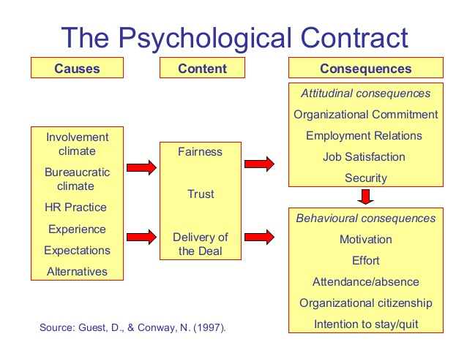
Following are the salient features of Guest Model of Psychological Contract:
- The psychological contract largely depends upon the extent to which the organization’s adopt and implement effect people management practices to promote the welfare of the employees and fulfill their expectations through employee-friendly practices.
- Employee commitment and satisfaction will increase if the psychological contract is positive, which is largely governed by the state of belief of employees that they would be treated fairly or transparently and that the employers are working upon their committed promises or the deal which was finalized mutually.

Managers need to initiate the process of re-establishing the psychological contract with employees through mutual trust and respect. Managers must view the resistance from their employee's perspective to understand the implicit terms which they hold and thoroughly revise them because unrevised terms will continue to create resistance and the change will not happen unless such revision is tackled first. Managers must make employees understand the rationale behind the change and the consequences to the organisation if the change objectives are not met. By making employees view the change from the perspective of the organisation, they will alter the terms of their obligations and will be able to re-establish the psychological contract and secure commitment based on these revised terms.
    - Scott and Jaffe’s resistance cycle
According to this model, people go through four phases of response to change: denial, resistance, exploration and commitment. Each phase corresponds to specific behaviours and emotions.
- Denial: It results from insufficient knowledge and occurs when individuals believe the change will have little or no impact on them. Denial can be overcome by involving individuals in the change process providing them with information about it and monitoring their perceptions. Managers should make them understand their role and how change will affect them personally. This stage is characterized by quietness and calm; managers should not mistake them for a positive emotion of being committed.
- Resistance: the resistance stage occurs when individuals begin to doubt the appropriateness of the change as a result of contradictory assessments, misunderstanding or lack of trust. During this stage manager should listen and acknowledge the feelings and engage in an open two-way communications that enables them to address their concerns, build and earn employee trust and take corrective actions.
- Exploration: the exploration phase reflects the progress towards acceptance of the change. In this phase, individuals have accepted the reality of it and are seeking positive outcomes in terms of opportunities and personal self-interests. Managers should continue to motivate and encourage individuals with communications, provide training and short term goals to make them focus on priorities and move closer to commitment.
- Acceptance: the acceptance phase is characterized by individuals demonstrating their commitment. Managers should therefore use milestone celebrations, rewards and team building to motivate individuals to re-establish the psychological contract.

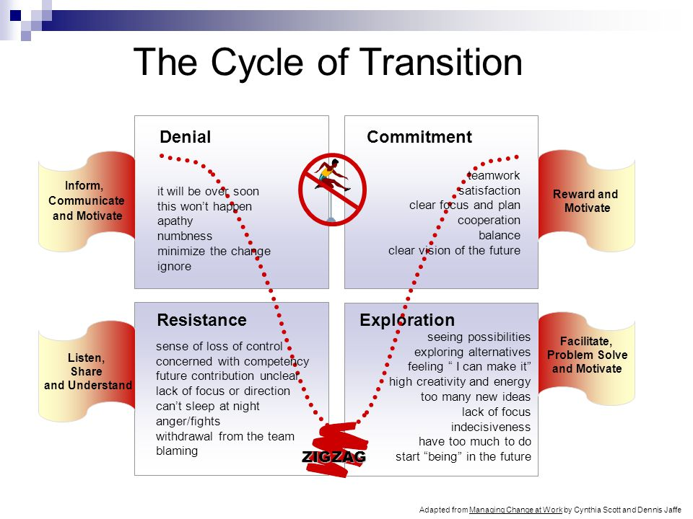

    - Kotter and Schlesinger’s Six Methods
Kotter and Schlesinger proposed six strategies to manage successfully the resistance to change.
- Education and Communication: education will avoid employees getting stuck in the denial phase for a long time and helps them adapt to new roles quickly whilst reducing uncertainty. Training on new knowledge and skills reduces fear of unknown and increases confidence with required changes to behaviour. Open communication that answers questions and encourages feedback will eliminate employee mistrust and will make them feel more involved with the change initiatives.
- Participation: it’s hard for an individual to resist a change decision in which they participated. People who participate will be well informed and committed to implement change as the process creates a psychological ownership of decisions and accountability for their success. Individuals who are allowed to contribute in change planning process won’t have any mistrust about the change and will be more committed to its success
- Facilitation and support: change affects employees’ roles and routines so managers’ support is essential to maintain a certain level of comfort and get the affected individuals adapt to the new role. Facilitating and providing a forum to share their concerns reduces fear and anxiety (which is one of the cause of resistance). Support activities like counselling, stress management and even emotional support will make an employee feel valued and encourage them in coping with change.
- Negotiation and agreement: negotiation is suitable when an individual will suffer loss due to the change. Managers will have to recognize the negative effects of it and negotiate with employees on their specific concerns providing incentives to them in exchange for acceptance.
- Manipulation and co-optation: manipulation involves intentionally using selective information in an attempt to influence individuals to accept change. Co-optation is about getting acceptance from employees by using tactics such as appointing an individual to an important position to gain acceptance. This can be the quick way to avoid resistance but can be dangerous if individuals become aware of manipulation.
- Coercion: when the motivation approach doesn’t work, managers have to use force or threat to overcome resistance. Coercion includes using explicit or implicit threats like promotion denial, bonus, etc. Sometimes coercion may be the only option available but managers need to take into consideration that individuals are likely to develop resentment and this might have long term negative effect.
As anyone can imagine, these strategies only provide a strategic framework to manage resistance. To successfully carry out them leadership is a key tool. Leadership provides a vision for change that can influence, direct and motivate people to take action and at the same time will reduce fear, uncertainty and improve employee morale. Unit 5 will explain about the leadership style needed in managing change

  - Benefits of Resistance
Contrary to popular opinion, resistance to change is not bad. Resistance can bring some benefits: It feels natural to assume that resistance to change is a bad thing. Resistance to change is actually a good thing. Resistance to change brings many benefits. If it were not for resistance, bad ideas would be initiated and implemented right along with the good ideas. Resistance causes us to deploy a strategy to get buy-in to get the good ideas implemented. When employees push back against change it forces us to (1) justify why change is necessary, (2) slow down, prioritize, strategize, and create supporting plans, and (3) involve employees, listen, and gather feedback.
- Encourage the management to re-examine its change proposals.
- Identify specific problem areas where change is likely to cause difficulties
- Encouraged to do a better job of communicating the change
- Resistance also gives management information about the intensity of employee emotions on an issue
- Encourage employee to think and talk more about a change

Activity 3.2
- Explain any two models of managing change resistance
- Discuss strategies change agents can use to overcome resistance to change.
- Discuss Sussan Heathfield 2012 contribution to minimizing resistance to change

Summary
In general, we can say that employees resist change when it is introduced poorly to them, when it affects how they do their work, and when they don't see the need for the changes. They also experience resistance to change when they are not involved in the decision to change, or at least, in making up the specific steps in the changes as they will affect them. When employees believe that their input was considered, they are less likely to experience resistance to change. Smart employers recognize that this is a given on the front end of any changes that you ask your employees to make. By the actions you take, when you introduce change to your organization, you can cause serious resistance to the changes. At the same time, with a proper introduction and adoption, you can minimize resistance and avoid the process of dealing with employee resistance to change
Reference:
Heathfield, S. (2012, March 19). How to Reduce Resistance to Change. About.com. from http://humanresources.about.com/od/resistancetochange/a/how-to-reduce-resistance-to-change.htm
Kotter, J (2001). What Leaders Really Do. Harvard Business Review.
Kotter, J. (1995) Leading Change: Why Transformation Efforts Fail, Harvard Business Review, March-April.

References: Bovey and Hede (2001), Strebel, (1996), Palmer, Dunford & Akin (2006), Bolognese (2002), Warr (2002), Bove and Hede (2002), (Sims, 2002).
Unit 4: Change Agent
- Introduction

Every organizationals change requires change agents. A change agent is anyone who has the skill and power to stimulate, facilitate, and coordinate the change effort. Change agents may be either external or internal. Both internal and external agents have advantages and disadvantages that will be explained further in this unit. The roles of a change agent depends with the change being carried out.

  - Objectives

At the end of this unit you must be able to
- Define the term change agent
- Distinguish between internal and external change agents
- Explain the advantages and disadvantages of engaging internal/external change agents
- Discuss change agent types
- Explain the roles of change agents
- Describe the fundamentals of change agents

  - Definition of Change Agent

A change agent is a person from inside or outside the organization who helps an organization transform itself by focusing on matters such as organizational effectiveness, improvement, and development. A change agent usually focuses his efforts on the effect of changing technologies, structures, and tasks on interpersonal and group relationships in the organization. The focus is on the people in the organization and their interactions.

A change agent is sometimes also called an agent of change or change advocate. Champion and change agent are sometimes used interchangeably, as well; however, there are some differences between the roles each one plays in supporting change, with a change agent having more responsibilities and accountability than a champion for ensuring that change happens successfully.

Though change is a continuous process involving managers at all levels, who should initiate change and how has to be deliberately decided in planned change. Planned change can be introduced through change agents. Change agent is the person who initiates change in the organisation to increase organisational effectiveness.

  - External and Internal Change Agents
Often people think that managers and executives must be change agents within their organizations. However, change agents are not limited to high-ranking employees. A change agent can be a lower tier worker with the right mix of skills, characteristics and authority to shepherd others through the transformation. For example, in a University set up it doesn’t mean that the Vice Chancellor is always the change agent an I.T officer can be a change agent on a project of introducing new ICT. A change agent can also be someone outside the organization; an external change agent is often a consultant hired to help with a change effort. Although a change agent can come from various positions within or outside an organization, a successful change agent is generally one who is well-respected by the individuals impacted by the organizational change, and one who is well-informed about the various facets of the project.
    - External change agents
External change agents are generally the behavioural scientists who specialise in human behaviour. They work as consultants for the company and devise its change strategy. The advantage of using an outside change agent is their objectivity and the ability to give honest feedback to management without fear of reprisal. They also bring perspectives from other organizations so they have a broad range of experience to share. Outside change agents are not as tied to traditions within an organization so may challenge the status quo.
The disadvantages of using an external change agent is that they don’t have a working knowledge and understanding of the company culture. They may be challenged with building relationships and becoming familiar with organizational “norms”, beliefs and accepted behaviors. The other disadvantage is the organizations ability to maintain momentum after the change agent leaves. Below are advantages and disadvantages of using external change agents.

Advantages of external consultants
- External consultants are unbiased and with an open mind in contrast with internal consultants.
- Because they are invited into the organisation, they have increased leverage (influence)
- Outsider is less constrained by organizational politics and conditioning as they do not depend upon the organisation for raises, approval or promotions.
- Because they usually have a very broad career base and other clients to fall back on they tend to have more independent attitude about risk-taking and confrontations with the client system.
- . Provides fresh ideas, concepts and objective perspective with less resistance
- Willing to assert, challenge, and question norms and institutional culture (they think outside the box)
- They are neutral and have no stake in the institution
- Brings skills, technique, information and experience from other institutions experiences that are not available from within the organization.
- Freedom from distraction from day to day operating responsibilities

Disadvantages of external consultants
- Might lack a good understanding about organisation’s culture, values and beliefs. Thus, they may not take those aspects into account while designing the change programme and it may be difficult to get employees to follow change programme and it may be difficult to get employees to follow the change. (might have fail to gather pertinent information))
- External consultants are not the one affected by the change and they may attempt to promote a tough, radical change on organisation.
- They do not have anything do with the repercussion (consequence) after the change is implemented
- May or may not be available when needed by the organization; may split time and commitments with other clients.
- High expense – fees can be costly
- Takes time to become familiar with system
- May create co-dependency or may abandon the system.

    - Internal change agents
They are continuously involved in the change process. They belong to the organisation only and depending on the need where the change is required, they are selected from different levels and departments. Internal change agents are usually the managers who are trained by the consultants (external change agents) to implement change as on ongoing process. They introduce change within the broad framework of change strategy devised by the external change agents. They also lead the members to implement the change process. Internal change agents may also be change advisors appointed from specific departments for specific periods. After the change programme is completed, they go to their original departments.
Advantages of using internal consultants
- Internal consultants have a deep understanding about their organisation, its system and people.
- They are likely to be readily available: they are there, ready and able to take on the job whenever evaluation is wanted
- Easy access to information
- Develops and keeps expertise and resources internal
- Creates and maintains norm of organization renewal from within
- Provides higher security and confidentiality
- May have trust and respect of others
- Has strong personal investment in success
Disadvantages of internal consultants
- They are too close to the system, their views tend to be subjective and be bound to the conventional (usual) way of thinking.
- May be biased; has already taken sides, or may be disliked or mistrusted by some stockholders
- Being too close to see what the problem is or having cognitive limitations
- Previous relationships may contribute to sub-grouping or fragmentation
- Takes CA away from other duties
- May be “part of the problem” or does not see it
- Is subject to organisational sanction and pressures as an employee - Compromised independence of the agent

    - External change agent vs internal change agent
The table below shows the differences between external and internal change agents

External Change Agent | Internal Change Agent
1. He is the outside consultant hired by any organisation. | 1. He is the inside consultant who is an employee of the organisation.
2. He is always a professional. | 2. He is not always a professional.
3. He works for a limited period of time for any organisation. | 3. His working period is not limited.
4. Hiring external change agent is expensive. | 4. Working with an internal change agent is economical for an organisation.
5. External change agent only outlines the change process. | 5. An internal change agent works for the implementation of the change process as well.
Table 4.1: external change agent vs internal change agent
Activity 4.1
  - Define change agent.
  - Distinguish between internal and external change agents.
  - Discuss the advantages and disadvantages of engaging external change agents
  - Explain the advantages and disadvantages of using internal change agents

  - Change Agent Types
Although little research has explored what type of change agent is most effective in a given situation, some research has identified different types of change agents according to their characteristics and methods of implementing change (Burke, 2011; Eikenberry, 2011; Mansfield, 2011; Thota, 2012). These include the following types.
4.4.1 Outside pressure type
These change agents work to change systems from outside the organization. They are not members of the company they are trying to change and use various pressure tactics such as mass demonstrations, civil disobedience, and violence to accomplish their objectives. Typically, they offer options that are more radical than the community might accept. This usually results in the possibility of examining many different change alternatives.
4.4.2 People-change-technology type
The focus of activity for this type of change agent is the individual. The change agent may be concerned with employee morale and motivation, including absenteeism, turnover, and the quality of work performed. The methods used include job enrichment, goal setting, and behavior modification. The major assumption underlying this orientation is that if individuals change their behavior, the organization will also change, providing enough people within the organization change. A manager can certainly assume the role of people-change-technology type and often do.
    - Analysis-for-the-top type
The focus of this change agent is on changing the organizational structure so as to improve output and efficiency. The change agent uses operations research, systems analysis, policy studies, and other forms of analytical approaches to change the organization's structure or technology. For example, the change might include introducing computerized information-processing systems. Many managers assume this role when implementing change.
    - Organization-development type
These change agents focus their attention on internal processes such as intergroup relations, communication, and decision making. Their intervention strategy is often called a cultural change approach, because they thoroughly analyze the culture of the targeted organization. This approach grew out of such areas as sensitivity training, team building, and survey feedback. Many managers assume the role of organization-development type when implementing change.
  - Role of a Change Agent

There are at least three distinct roles that change agents play: consulting, training, and research (Carnall, 2008; Dawson, 2010; Stephen, 2010; Tidd, 2010). A manager can and often does perform each of these functions. An outside change agent can perform these activities as well.

Consulting
As a consultant, the agent places employees in touch with data from outside the organization or helping organization members to generate data from within the organization. The overall purpose is to help employees find solutions to problems through analysis of valid data.

Training
In addition to performing the role of consultant, the agent may function as a trainer. Here the manager helps organization members learn how to use data to effect change. The change agent has a dual purpose as trainer: (1) to help organization members derive implications for action from the present data and (2) to provide organization members with a new set of skills—the ability to retrieve, translate, and use new data to solve future problems.

Research
Closely associated with the previous role, the manager may assume the role of researcher. As researcher, the manager may train organization members in the skills needed for valid evaluation of the effectiveness of action plans that have been implemented. Furthermore, as part of the overall intervention strategy, the manager will design an evaluation component that can be used in solving not only the current problem but also future problems.

In general, the role of a change agent varies with the nature of the organisation, problem and management, change agent usually performs the following tasks:
1. He announces the need for change in the organisation. Members usually want to maintain status quo which is resistant to change. Change agents help to overcome this resistance.
2. He diagnoses the present situation in the organisation, foresees changes in the environment and helps the client company in adapting to the changing environment.
3. He helps in smoothly carrying out the change process. People accept change naturally without feeling that they are forced to accept it.
4. He formulates strategies for change. These are known as change interventions or OD (organisation Development) interventions.
5. He trains the internal change agents to implement the change process and introduce it further in the organisation. Change, thus, becomes an on-going process in the light of ever-changing dynamic external environment.
6. He uses behavioural skills to deal with emotional and social problems of employees in accepting and implementing change.

A change agent, thus, acts as a:
1. Facilitator:
He facilitates change by developing awareness about the importance of change.
2. Consultant:
He draws major plan for change based on his diagnostic skills.
3. Counselor:
He studies the attitudes, personality, perception, beliefs and expectations of organisational members to the change process and motivates them to accept change and continue in the changed environment till a change is introduced again.

  - Fundamentals for Change Agents

Several researchers have identified fundamentals for change agent needed for successful change (Anderson, 2011; deBruijn, 2011; Jain, 2011; Lindegaard, 2011; McCabe, 2011). These factors briefly defined in the following list, refer to the way in which change agents must manage change rather than to any personal characteristics they may possess.
Hemophily
The more alike the change agent and employees are, the more likely it is that the change agent will be successful. Similarity between the change agent and organization members results in acceptance of the change agent by the employees and understanding of the employees by the change agent.
Empathy
This is the skill of understanding the feelings of another person. Empathy leads to improved communication and understanding between the change agent and organization members.
Linkage
This refers to the extent to which the change agent and organization members are tied together in collaborative activities. The greater the collaborative involvement (the tighter the linkage), the more likely the change agent will be successful.
Proximity
This refers to the physical and psychological closeness of the change agent and organization members. The greater the proximity between the change agent and the organization members, the more likely the change agent will be successful. Increasing proximity makes it easier to develop collaborative linkages. Proximity also facilitates the development of empathy between change agent and organization members. Proximity has relevance to open door policy and the visibility of the change agent during working hours.
Structuring
This factor refers to the ability of the change agent and organization members to clearly plan and organize their activities concerning the change effort. A clearly designed change effort is more likely to be understood and implemented by the employees.
Capacity
This factor is a characteristic of the organization. It refers to the company's capability of providing the resources needed for a successful change effort. A successful change effort requires an adequate amount of resources.
Openness
This characteristic refers to the degree to which the change agent and organization members are willing to hear, respond to, and be influenced by one another. The preceding six factors can all facilitate the development of such openness or, when absent, they can hinder the development of openness between the change agent and organization members.
Reward
This refers to the nature and variety of potential positive outcomes of the change effort that might accrue to the change agent and organization members. Change efforts should be designed so that the employees are rewarded for changing.
Energy
This refers to the amount of physical and psychological effort the change agent and organization members are able and willing to expend on the change effort. When day-to-day problems are so pressing that they sap all of the employee's energy, it diminishes the energy they can devote to the change effort.
Activity 4.2
- Describe change agent types.
- Explain the roles of a change agent
- Discuss any five fundamentals for change agents

  - Summary
Every change programme needs a change agent to lead. There are a lot of factors to be considered on whether to hire an external or use an internal change agent. The success of any change effort depends heavily on the quality and workability of the relationship between the change agent ,the key decision makers and employees of an organisation.

Reference
Anderson, L. A. (2011). The change leader’s roadmap: How to navigate your organization’s transformation. New York, NY: Routledge.

Burke, W. W. (2011). Organizational change: Theory and practice. Thousand Oaks, CA: Sage.

Carnall, C. (2008). Managing change in organizations. Upper Saddle River, NJ: Prentice Hall.

Dawson, P. M. B. (2010). Managing change, creativity and innovation. Thousand Oaks, CA: Sage.

deBruijn, H. (2011). Managing professionals. New York, NY: Routledge.

Eikenberry, K. (2011). Championing change: Creating remarkable leaders. New York, NY:Wiley.
Jain, R. (2011). Managing research, development and innovation: Managing the unmanageable. New York, NY: Wiley.

Lindegaard, S. (2011). The open innovation revolution: Essentials, roadblocks, and leadership skills. New York, NY: Wiley.
Mansfield, J. (2011). The nature of change: An introductory text to designing complex systems and managing change. London, UK: Imperial College Press.

McCabe, S. (2011). Corporate strategy in construction: Understanding today’s theory and practice. New York, NY: Wiley.

Stephen, T. (2010). Successfully managing change in organizations. New York, NY: Industrial Press.
Thota, H. (2012). Key concepts in innovation. New York, NY: Palgrave Macmillan.

Tidd, J. (2010). Managing innovation: Integrating technology, market and organizational
change. New York, NY: Wiley.

Tschirky, H. (2011). Managing innovation-driven companies: Approaches in practice. New York, NY: Palgrave Macmillan.

Unit 5
Leading Change
Introduction
For change to be successful the leader must be able to apply particular models or approaches relating to leading change. It is of paramount importance that a leader understands his or her role in leading change. He or she must possess certain characteristic that will enable him or her to lead change effectively. In this unit we will discuss the difference between managers and leaders, types of leader, roles that leaders play, leadership styles relevant for managing change, how to persevere during a change process

Objectives
By the end of this unit you should be able to:
- Differentiate between a manager and a lead
- apply particular models or approaches relating to Leading Change to a given scenario.
- Understand different leadership styles relevant for managing change
- Explain roles leaders play during change management
- Explain how to persevere during change process

  - A Manager and a Leader
Not all managers are leaders. The main difference between leaders and managers is that leaders have people follow them while managers have people who work for them. A successful change programme needs both a strong leader and manager to get their team on board to follow them towards their vision of success. Leadership is about getting people to understand and believe in your vision and to work with you to achieve your goals while managing is more about administering and making sure the day-to-day things are happening as they should.
Warren Bennis (1994) developed a useful comparison of the differences between management and leadership see table below. It shows some of the different qualities of leader.
Table 5.1: Managers and leaders
A manager | A leader
Administers | Innovates
Is a copy | Is an original
Maintains | Develops
Focuses on systems and structure | Focuses on people
Relies on control | Inspires trust
Has a short-range view | Has a long-range perspective
Asks how and when | Asks why
Has his eye on the bottom line | Has his eye on the horizon
Imitates | Originates
Accepts the status quo | Challenges the status quo
Classic good soldier | His own person
Does things right | Does the right thing
Source: Bennis (1994)

Kotter (1996) echoes the ideas of Bennis. He says, ‘we have raised a generation of very talented people to be managers, not leader/managers, and vision is not a component of effective management. The management equivalent to vision creation is planning.’ He says that leaders are different from managers. ‘They don’t make plans; they don’t solve problems; they don’t even organise people. What leaders really do is prepare organizations for change and help them cope as they struggle through it.’ He identifies three areas of focus for leaders and contrasts these with the typical focus of a manager:
- setting direction versus planning and budgeting;
- aligning people versus organizing and staffing;
- motivating people versus controlling and problem solving.
    - Who has to lead change
Senge et al, 1999 has different views from Benis (1994) about who is supposed to lead change. He says that successful leadership of change does not have to come from the top of an organization. It comes from within the organization. He remarks that senior executives do not have as much power to change things as they would like to think.
He asks why we are struggling so much with changing our organizations, and he attacks our dependence on the ‘hero leader’. He claims it results in a vicious circle. The circle begins with a crisis, which leads to the search for a new CEO in whom all hopes are invested. The new CEO acts proactively and aggressively, and makes some dramatic short-term improvements such as cutting costs and improving productivity. Everyone then falls in line to please the new CEO, who does not suffer fools gladly. Employees comply rather than work hard to challenge the status quo, and a new crisis inevitably occurs. This vicious circle does not result in new thinking or organizational learning or renewal, or even growth, and in turn feeds our desire to find new hero-leaders. See Figure 5.1
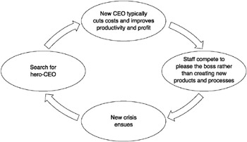
Figure 5.1: The search for a hero-CEO
Source: Senge et al (1999)
Senge offers some truths about organization change, which counteract the reliance on top-level vision set out by Bennis and Kotter.
- Little significant change can occur if it is driven from the top.
- CEO programmes rolled out from the top are a great way to foster cynicism and distract everyone from real efforts to change.
- Top management buy-in is a poor substitute for genuine commitment and learning capabilities at all levels in an organization.
Senge main argument is that the top executives are too busy to be responsible for envisaging and tackling the enormous range of challenges that present themselves when fundamental change is needed.
  - Types of Leaders
Senge identified three important, interconnected types of leader: local line leaders, executive leaders and network leaders.
    - Local line leaders
These are the front-line managers who design the products and services and make the core processes work. Without the commitment of these people, no significant change will happen. These people are usually very focused on their own teams and customers. They rely on network leaders to link them with other parts of the organization, and on executive leaders to create the right infrastructure for good ideas to emerge and take root.

    - Executive leaders
These are management board members. Senge does not believe that all change starts here. Rather, he states that these leaders are responsible for three key things: designing the right innovation environment and the right infrastructure for assessment and reward, teaching and mentoring local line leaders, and serving as role models to demonstrate their commitment to values and purpose.
5.2.3 Network leaders
Senge makes the point that the really significant organizational challenges occur at the interfaces between project groups, functions and teams. Network leaders are people who work at these interfaces. They are guides, advisors, active helpers and accessors (helping groups of people to get resource from elsewhere), working in partnership with line leaders. They often have the insight to help local line leaders to move forward and make changes happen across the organization.

Senge argues that there have to be an interconnection between these three types of leaders however in reality this is difficult mainly because:
- Executive leaders are busy, hard-to-get-hold-of people who can become quite disconnected from their local line leaders.
- Executive leaders and local line leaders rarely meet face to face and communicate by e-mail, if at all.
- Network leaders, such as internal consultants or process facilitators, are often diverted from their leadership roles by requests either to perform expert tasks or to implement HR-led initiatives.
- Network leaders may be busy and effective, but are usually undervalued as leaders of change. They often have to battle to get recognized as important players in the organization.

  - Key Roles for Successful Change
Mary Beth O’Neill (2000) agrees with Senge’s idea of interconnected leaders, and identifies four specific leadership roles necessary for successful and sustained change efforts in organizations. She uses Daryl Conner’s work on family therapy as her model for the change process, and identifies the important roles as sponsor, implementer, advocate and agent. See below table.
Table 5.2: Roles in a change process
Role | Description | Hint
Sponsor | Has the authority to make the change happen.  Has control of resources. | Needs to have a clear vision for the change.  Identify goals and measurable outcomes.
Sustaining sponsor | Sponsors change in own area, although top-level responsibility lies further up the hierarchy. | Must be careful not to transmit cynicism
Implementer | Implements the change.  Reports to sponsor.  Responsible for giving live feedback to the sponsor on change progress. | Needs to listen, enquire and clarify questions with the sponsor at the start of an initiative
Change agent | Facilitator of change. Helps sponsor and implementers stay aligned.  Keeps sponsor on board.  No direct authority over implementers. | Acts as data gatherer, educator, advisor, meeting facilitator, coach
Advocate | Has an idea. Needs a sponsor to make it happen.  Usually highly motivated. | Must make idea appealing to sponsor
Source: adapted from O’Neill (2000)

    - Sponsor
The sponsor has the authority to make the change happen. He or she legitimizes and sanctions the change, and has line authority over the people who will implement the change and control of resources – such as time, money and people. There are also sustaining sponsors who are responsible for sponsoring change in their own area.
Good sponsors have a clear vision for the change. They identify goals and measurable outcomes for the initiative. Sustaining sponsors must be careful not to telegraph cynicism about the change to the team of implementers.
    - Implementer
Implementers are the people who must actually implement the change. They have direct line responsibilities to the sponsor. Their job is to provide the sponsor with live feedback from the change initiative. They can save the sponsor from tunnel vision, or from being surprised by obstacles that those closest to the change sometimes notice first.
Implementers are most effective when they listen, inquire and clarify their questions and concerns with the sponsor at the beginning of an initiative. This means they can commit to an effort rather than falsely complying early on and sabotaging later.
    - Change agent
A change agent is the facilitator of the change. He or she helps the sponsor and the implementers stay aligned with each other. The effectiveness of this role depends on the sponsor not abandoning the change agent to the implementers. The sponsor must not ‘drop the ball’. When this happens the change agent can over-function, making the system ineffective and unbalanced, and the change temporary.

The change agent acts as data gatherer, educator, advisor, meeting facilitator and coach. Most often he or she has no direct line authority over the implementers, and is therefore in a naturally occurring triangle among sponsor–implementer–agent.
    - Advocate
An advocate has an idea about how a change can happen but needs a sponsor for his or her idea. All change needs to be sponsored. Advocates are often passionate and highly motivated to make the change happen. They must remember the key factor, which is to get a sponsor. Without this, advocates become frustrated and demoralized. Shrewd advocates promote ideas by showing their compatibility with issues near and dear to sponsors’ change projects and goals.
Activity 5.1
- Discuss the difference between a manager and a leader.
- Explain any four roles of change process.
- Identify and explain type of leader identified by Senge.
- Critically analyse Senge et al, 1999 views on who has to lead change.

  - Leadership styles for Change Management
    - Goleman leadership that gets results
Daniel Goleman (2000) developed a set of six distinct leadership styles through studying the performance of over 3,800 executives worldwide. These six leadership styles, arising from various different components of emotional intelligence, are used interchangeably by the best leaders. He encourages leaders to view the styles as six golf clubs, with each one being used in a different situation. Goleman also found that each style taken individually has a unique effect on organizational climate over time, some positive and some negative. This in turn has a major influence on business results.
Goleman links the competence of leaders directly to business results, but also identifies the situations in which each style is effective:
- Coercive style. Only to be used sparingly if a crisis arises. This is a useful style to employ if urgent changes are required now, but must be combined with other styles for positive results long term. Negative effects such as stress and mistrust result if this style is overused.
- Authoritative style. Useful when a turnaround is required and the leader is credible and enthusiastic. This is the ‘visionary’ leadership style. Goleman indicates that this style will only work if the leader is well respected by his or her people, and is genuinely enthusiastic about the change required. He does acknowledge the strongly positive effect of this approach, given the right prevailing conditions.
- Affiliative style. This style helps to repair broken relationships and establish trust. It can be useful when the going gets tough in a change process and people are struggling. However, it must be used with other styles to be effective in setting direction and creating progress.
- Democratic. This is an effective style to use when the team knows more about the situation than the leader does. They will be able to come up with ideas and create plans with the leader operating as facilitator. However it is not useful for inexperienced team members as they will go round in circles and fail to deliver.
- Pacesetting. This style can be used effectively with a highly motivated, competent team, but does not lead to positive results long term if used in isolation. Overuse of this style alone results in exhausted staff who feel directionless and unrewarded. The leader needs to switch out of this style to move into a change process rather than simply drive for more of the same.
- Coaching. This is an appropriate style to use if individuals need to acquire new skills or knowledge as part of changes being made

    - Cameron and Green inner and outer leadership
Cameroon and greener argues that it is key to link the phase of the change and the type of leadership needed at each phase. Their argument is that there is need for flexibility in leadership styles as the change moves from one phase into another phase. They identified both the outer leadership and inner leadership requirements of a leader of change for each phase.

Table 5.3: Leadership of change phase by phase, comparing inner and outer leadership requirements
Phase of change | Outer leadership – observable actions of the leader | Inner leadership – what goes on inside the leader
1. Establishing the need for change  The leader illuminates a problem area through discussion | Influencing, understanding, researching, presenting, listening | Managing emotions, maintaining integrity, being courageous, being patient, knowing yourself, judging whether you really have the energy to do this
2. Building the change team  The leader brings the right people together and establishes momentum through teamwork. | Chairing meetings, connecting agendas, facilitating discussion, building relationships, building teams, cutting through the politics | Social and organizational awareness, self-awareness, managing emotions, adaptability, taking initiative, having the drive to achieve, maintaining energy despite knock-backs
3. Creating vision and values  The leader works with the group to build a picture of success. | Initiating ideas, brainstorming, encouraging divergent and creative thinking, challenging others constructively, envisaging the future, facilitating agreement | Strategic thinking, taking time to reflect, social awareness, drive to achieve, managing emotions
4. Communicating and engaging  The leader plays his or her role in communicating direction, giving it meaning, being clear about timescale and letting people know what part they will be playing. | Persuading and engaging, presenting with passion, listening, being assertive, being creative with ways of communicating | Patience, analysis of how to present to different audiences, managing emotions with regard to other people’s resistance, social awareness, adaptability, empathy
5. Empowering others  The leader entrusts those who have been involved in the creation of the new vision with key tasks. | Clear target setting, good delegation, managing without micromanaging or abdicating, coaching | Integrity, trust, patience, drive to achieve, steadiness of purpose, empathy
6. Noticing improvements and energizing  The leader stays interested in the process. This involves the ability to juggle lots of different projects and initiatives | Playing the sponsorship role well, walking the talk, rewarding and sharing success, building on new ideas | Steadiness of purpose, organizational and social awareness, empathy, managing emotions, drive to achieve
7. Consolidating  The leader encourages people to take stock of where they are, and reflect on how much has been achieved | Reviewing objectively, celebrating success, giving positive feedback before moving on to what’s next | Social awareness, empathy, drive to achieve, taking time to reflect, steadiness of purpose

  - Persevering in Leading Change
Rosabeth Moss Kanter (2002) highlights the need for keeping going in the change process, even when it gets tough. She says the difficulties will come after the change is begun.
Kanter says that leaders need to employ the following strategies to ensure that a change process is sustained beyond the first flourish:
- Tune into the environment. Create a network of listening posts to listen and learn from customers.
- Challenge the prevailing organizational wisdom. Promote kaleidoscopic thinking. Send people far afield, rotate jobs and create interdisciplinary project teams to get people to question their assumptions.
- Communicate a compelling aspiration. This is not just about communicating a picture of what could be, it is an appeal to better ourselves and become something more. The aspiration needs to be compelling as there are so many sources of resistance to overcome.
- Build coalitions. Kanter says that the coalition-building step, though obvious, is one of the most neglected steps in the change process. She says that change leaders need the involvement of people who have the resources, the knowledge and the political clout to make things happen.
- Transfer ownership to a working team. Once a coalition is formed, others should be brought on board to focus on implementation. Leaders need to stay involved to guarantee time and resources for implementers. The implementation team can then build its own identity and concentrate on the task.
- Learn to persevere. Kanter says that everything can look like a failure in the middle. If you stick with the process through the difficult times (see box), good things may emerge. The beginning is exciting and the end satisfying. It is the hard work in the middle that necessitates the leader’s perseverance.
- Make everyone a hero. Leaders need to remember to reward and recognize achievements. This skill is often underused in organizations, and it is often free! This part of the cycle is important to motivate people to give them the energy to tackle the next change process.

  - STICKY MOMENTS IN THE MIDDLE OF CHANGE AND HOW TO GET UNSTUCK:

- Forecasts fall short. Change leaders must be prepared to accept serious departures from plans, especially when they are doing something new and different.
- Roads curve. Expect the unexpected. Do not panic when the path of change takes a twist or a turn.
- Momentum slows. When the going gets tough it is important to review what has been achieved and what remains – and to revisit the mission.
- Critics emerge. Critics will emerge in the middle when they begin to realize the impact of proposed changes. Change leaders should respond to this, remove obstacles and move forward.
Source: Kanter (2002)
Activity 5.2
- Explain Rosabeth Moss Kanter (2002) strategies to ensure that a change process is sustained beyond the first flourish.
- Think of any organisational change that you involved. Did the ‘sticky moments’ suggested by Rosabeth Moss Kanter arise, and how were they dealt with? What could have been done differently by those leading the change?
- Discuss Daniel Goleman (2000) six distinct leadership styles.

5.7 Summary
Different metaphors of change lead to different assumptions about what good leaders do. We believe that the most effective ideas about change combine a number of metaphors, bringing the maximum benefits and avoiding the pitfalls of blinkered thinking. Different metaphors of the change process imply different leadership roles. Senge advocates dispersed leadership, identifying three key types of leader in an organizational system. If these three roles are in place and are well connected, then change will happen naturally. Mary Beth O’Neill names four key leadership roles in any change process. Inner leadership is about what goes on inside the leader. Outer leadership is about what the leader does. Outer and inner leadership are both important for achieving organizational change. Daniel Goleman defines six leadership styles. A leader can select the right style for the right situation, taking into account the necessary conditions for success and long-term consequences.

References
Bennis, W. G. (1994). On becoming a leader. Reading, Mass: Perseus Books.
Daniel Goleman, Richard Boyatzis and Annie McKee, Primal Leadership, HBS Press, 2004
Elisabet, ., Marcus, L. S., Mueller, J. M., & Rose, M. B. (2000). Elizabeth I: Collected works. Chicago: University of Chicago Press
Goleman, D. (January 01, 2000). Leadership that gets results. Harvard Business Review, 78, 2, 78-90.
In Allison, S. T., In Goethals, G. R., & In Kramer, R. M. (2017). Handbook of heroism and heroic leadership.
Kanter, R. M. (1997). Rosabeth Moss Kanter on the frontiers of management. Boston, Mass.: Harvard Business School Press
Kotter, J. P. (1996). Leading change. Boston, Mass: Harvard Business School Press.
Senge, P. M. (1999). The dance of change: The challenges of sustaining momentum in learning organizations. New York: Currency/Doubleday.

UNIT 6: Innovation
Work Plan
Instructions
Please go through Unit 6 of the main module attached on the platform BHIR 408 Managing Change and Innovation before attempting the activities.
Also go through the attached Video on week 6 Innovation.
Book for a chat with the facilitator to discuss grey areas.
Attempt the examination, it covers the six weeks of study.

FACULTY OF COMMERCE AND LAW

DEPARTMENT OF BUSINESS MANAGEMENT

MANAGING CHANGE AND INNOVATION COURSE OVERVIEW

Week 6 Objectives: Innovation

By the end of this week you must be able to
- define innovation
- discuss aspects derived from innovation definition
- examine the main external factors which promote change
- explain theories of innovation
- differentiate innovation from creativity
- explain essentials of innovative institutions/companies

